FLOOPIS’S

Recently I asked a couple cousins if they remembered floopis's and got mostly "No" answers. I was kind of surprised since they were such a treat at our house growing up.

A floopis is a triangle shaped deep fried (in a frying pan) light pastry covered with white powdered sugar. My mother got the recipe from (Great) Aunt Theresa via Grandma (Amelia).

During the 50s, some of the Ritzenthalers would go out to the Kromer farm in the fall to "help" harvest. We would pick bushels of apples and grapes of which Uncle Aaron and Aunt Theresa would share the bounty. Once home, Mom would make jelly and can applesauce, sometimes with Grandma Amelia. Us kids were a big help to the adults. Much of my time was spent with cousin Philip helping him with his chores, exploring the farm and dropping down out of the apple trees to ride the pigs.
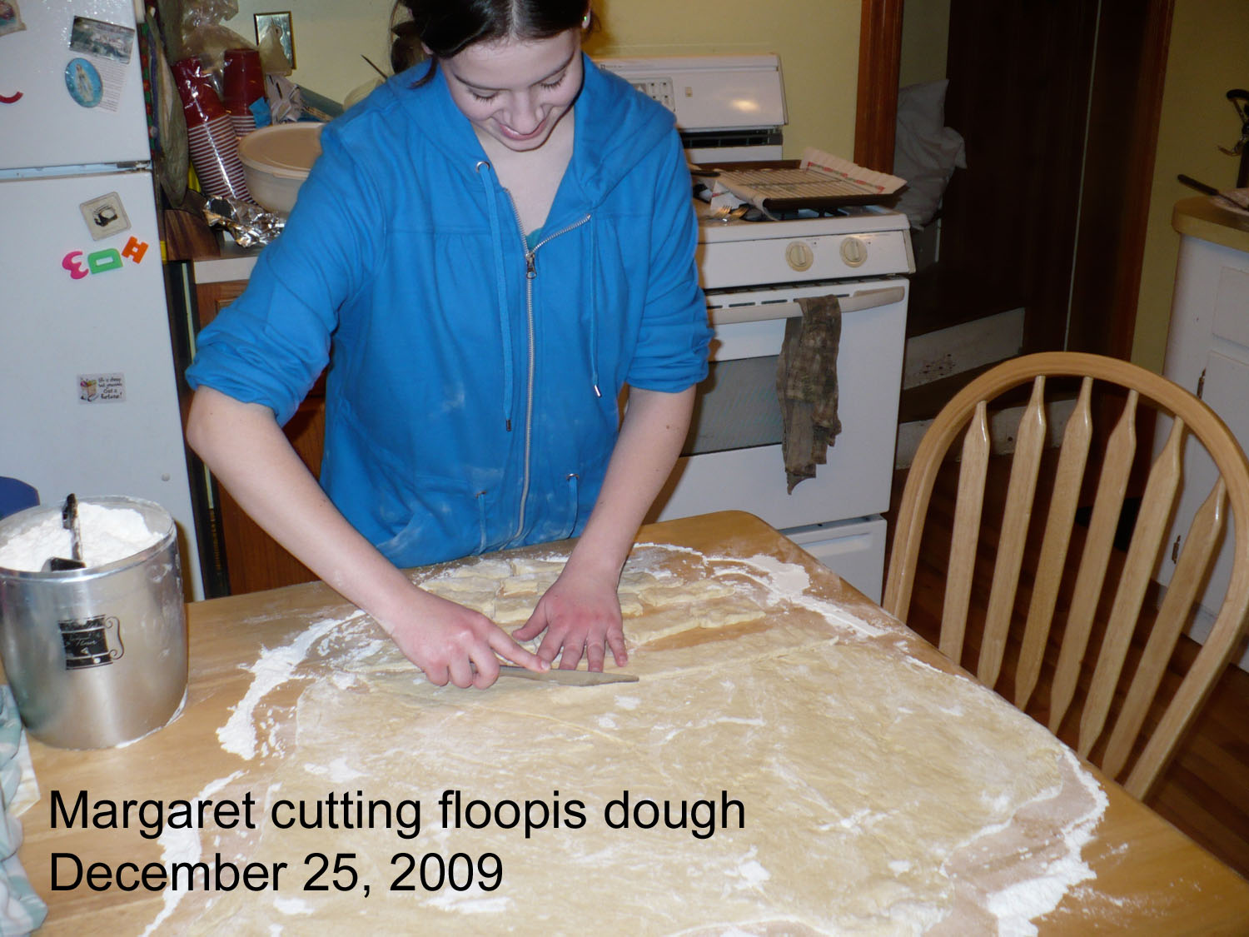
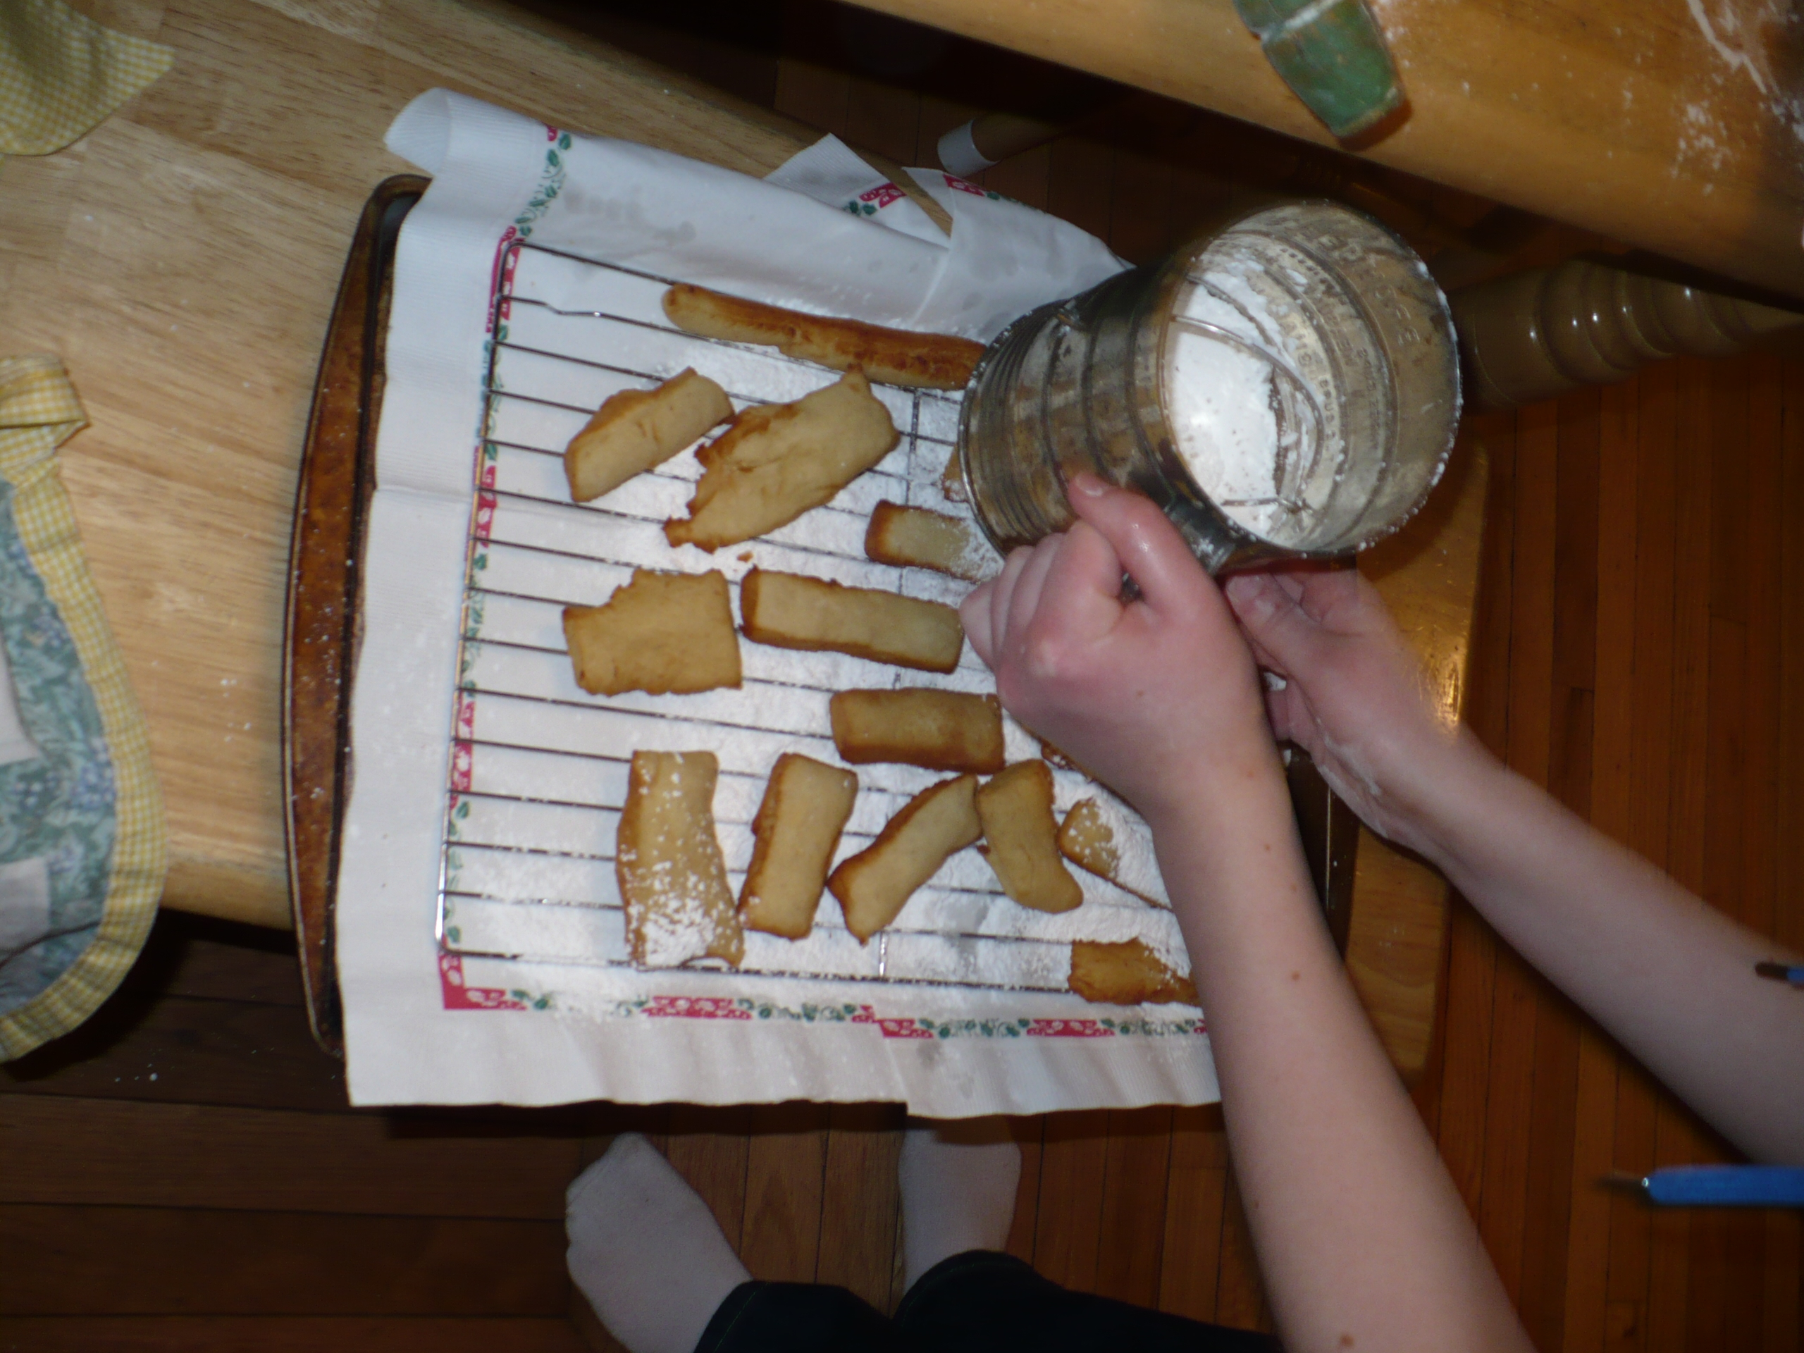
Aunt Theresa with the help of Joan, Oddie, Amelia and others would prepare a snack for all of us, floopis's. This visit was quite different from the reunions that were held at the farm. During one of these harvest visits my mother, Virginia, asked for the floopis recipe. Aunt Theresa said that she would write it down when she had time and get it to her via Amelia to share with all of Amelia's kids. The recipe for floopis's was/is a very old family recipe but, when Mom got the recipe, it was unusable. Part of the recipe was in German, phrases like handful of this or a schnivel of that, use grandma’s big bowl for, put in just enough and so on. Amelia said that she could translate the German but she didn’t know what some of the measurements were and couldn’t help with that. It was decided that the next visit that floopis’s were made, someone would measure and write down every move that Aunt Theresa made.

And thus floopis’s were passed to another generation. Mom cut the recipe to ¼ of Aunt Theresa’s and still had enough to feed the entire neighborhood. Over the years mom made them two or three times a year. After mom died Marsia would make them during the Christmas Season and now Lucy (Doug’s wife) makes them on Christmas day for all of us.

Some time ago (2004) I was reminiscing with Aaron Kromer II and when we started talking about floopis’s I was given some new information. He said they always looked forward to when his mom would make floopis’s but only the left over batter became pastry. Aunt Theresa first made several floopis kuchens and then came the frying of the pastries. This helps to explain why the original recipe was so enormous.

Recently (Nov 2009) Bob Mieyal, Fred Lautner (Amy’s husband), Brian Reynolds (Alissa’s husband) and I went to Mississippi to do post hurricane Katrina re-construction. While we were in Bay St. Louis, Mississippi a portion of our group was going to take a day to go to New Orleans (sight seeing). One of the guys told the fellow that was taking them to make sure he got them to try some beignets (pronounced "ben-YAYS"). Someone else said ben what ? What is that ? As the guy was describing the beignets in great detail I mumbled to myself, out loud, that sounds like floopis's. Another guy standing next to me said yea Deutsch.

You have heard of floopis's ?? He had and that is what a beignets is, a New Orleans floopis.

First time I have ever talked to anyone outside of the immediate family that had heard of floopis's.

