AUNT HANNAH

Who was Aunt Hannah? I know that she lived with Grandma & Grandpa but to whom was she related?

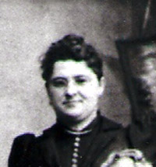
I always remember Aunt Hannah, I thought she was an aunt to Grandma or Grandpa but not really sure which one. I have the impression that she was from the Kromer side, that the house, Grandma and Grandpa lived in was hers and they inherited it for taking care of her. That is just my thoughts. Aunt Alba knew her too, that’s why I think she came from the Kromer side. I can still see her in that front room, that was hers. She was old then, older than our Grandparents. For all I know, she may have come from the Ritzenthaler side. INTERESTING!!!
-JUDY

I don't know how she was related to us. All I remember is that she lived with Grandma and Grandpa in the house on Monroe St. that was in the same block as Camp's - the little store on the corner. I used to play with the little girl next door, Sue Harrison. I kind of always got the impression that Aunt Hannah was difficult or contrary and maybe even mean tempered. It seems that when anyone would talk about her it was in a negative way.
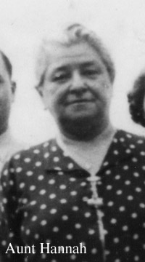
-Barb
I talked with Mom and this is what she recalls about Aunt Hannah. She thinks that she was related to the Grandpa Ritz somehow and that her last name was Steinen. Grandma and Grandpa moved in with Aunt Hannah when they lost their home during the Depression. Her house was located on Monroe St. near Park St. just down from Columbus Ave. Aunt Albie (Grandma's sister) lived upstairs at the time also. Aunt Hannah had dementia so Grandma and Grandpa took care of her and continued to do so until she died. Then they moved to another house on Monroe St. near Central Park, the one we all know, and rented the downstairs. Aunt Albie continued to live with them.
-Roy

Aunt Hannah was gramma Rosa Mainzer (Kromer)'s sister. She was married to a "Steinen" and they went to Canada to farm on land that was supposed to be "given" to them by the government. No one ever knew if they were divorced or lost the land or what - but she returned from Canada alone. And then gramma Rosa - who, of course, was Hannah's sister arranged for Aunt Amelia and Uncle George to live with her - and I think the provision was that they would care for her the rest of her life - at any rate- that's how it turned out.
- Mary (Kromer) Icsman

Dad (Albert Ritzenthaler) used to tell a story about Aunt Hannah. It seems, shortly after they moved in with her, one of the younger kids asked Aunt Hannah to make them a peanut butter and jelly sandwich. Aunt Hannah got all the stuff out and asked how he wanted the sandwich made, he said peanut butter on the bottom and jelly on top. She put the peanut butter on the bottom side of the bread and jelly on the top side and gave it to him. He took it and went crying to Mom (Amelia), look what she did, look what she did.

Growing up, any time we would say something that was goofy or out of place, dad would respond with, “You sound just like my Aunt Hannah”.

The impression Aunt Hannah had on Dad became evident when he forbade Amy from considering that name when she was expecting a daughter.
-Paul

