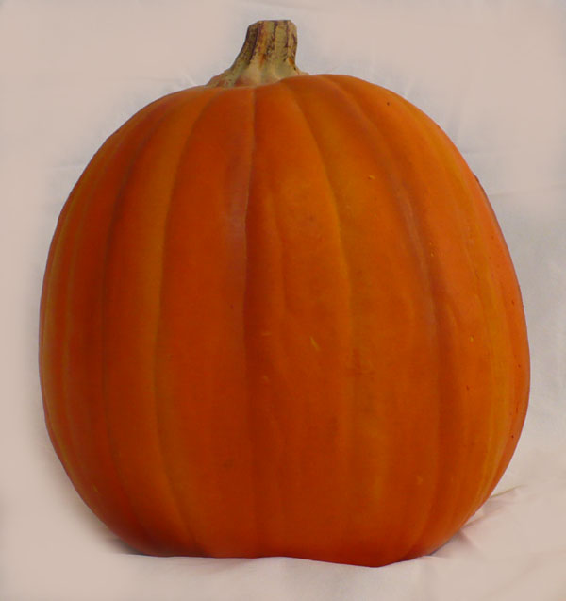
The Pumpkin Story

As told by Joe Ritzenthaler, Summer 2003
On a cold October night there was a discussion about WW II Dive Bombers regarding the trajectory of the bomb after it was released. One of the brothers contended that when a dive bomber dove to drop a bomb the bomb would loop over the plane (or the plane would loop under the bomb). Anyway, a heated discussion erupted (along with the consumption of beer) regarding the physics of this maneuver and if it was even possible. To prove or disprove the theory they headed out the door, nabbed pumpkin from somewhere, jumped in a car and commenced with the experiment. The pumpkin was thrown out the car window and ....... Joe would not divulge exactly all that happened next but the pumpkin ended up rolling through an intersection and hit something? Next thing everyone seems to agree on is the kitchen door flew open and the brothers came in laughing like hell.
Kip

Hi Paul,
Here is my Mom's (Aunt Gerry) recollection of that evening
The brothers were discussing the trajectory of the A-bomb at Hiroshima. The discussion turned to the big question: Did the A-bomb drop straight down or did it have to be released prior to reaching the target? They decided to test their theories with a pumpkin as the Bomb. One brother stood at the side of the road to see where the pumpkin would land. The others took off in the car and dropped the pumpkin at the point where he was standing. We never heard where it landed, but the pumpkin rolled all the way down Perkins Ave, and they came in after the "experiment" laughing like hell.

Roy's recollection
When I asked my Dad what he was trying to prove with the pumpkin drop he was philosophical and said "If a car is traveling at 50mph is a fly sitting inside the car also traveling at 50mph? Because of this fact we have a federal mandatory seat belt law! "

It was an almost perfect fall evening in 1958 and the family had gathered at Al & Gini's on Campbell Street, just south of Perkins Avenue. Clete & Gini, Tony & Gerry and Joe & Bev were all in attendance along with most of their children.

The guys went to rush-a couple jugs and then as was the custom at these weekly assemblies, a discussion ensued. As the beer supply dwindled a discussion of bombers and bombing during World War II escalated in intensity. Both dive bombers and high altitude bombers were discussed and demonstrations became more and more dramatic. Finally a large scale experiment was called for and designed by the brothers.

Albert had a very large vegetable garden and it was decided that a pumpkin would be the appropriate produce for the bomber experiment. A large pumpkin was chosen and the four got into a car and drove to the end of the long driveway. At this point it was decided that an observer would stand at the end of the driveway and as the speeding car passed the pumpkin would be dropped as a bomb. The observer was to determine if the bomb dropped straight down or continued forward while falling.

Joe was to be the observer and stood at the end of the driveway as the other three drove south on Campbell Street to turn around for the bombing run. Two of the boys hung out the window holding the pumpkin to make the perfect drop. As they headed up Campbell Street toward Joe, something happened and the bomb was released prematurely. Initial aggravation turned into uncontrolled laughter as the pumpkin hit the ground rolling right at and then chasing Joe. Joe was able to avoid the wayward pumpkin and it was decided that another beer was in order rather than another bombing run.

That laughter has now lasted fifty years.

